Fly-Catching Frog
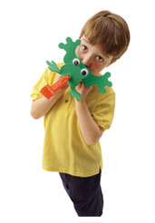

Craft Materials Needed:
- Frog outline – See below
- Green Craft Foam
- Two large googly eyes
- Glue
- Red Party Blower

- Download the frog outline
- Cut it out and trace it onto a piece
Of green craft foam.
- Cut out the shape, cutting 2 small X’s where indicated. Glue on two large googly eyes and allow the glue to dry completely.
- To add the tongue fold back the frogs head and push the mouthpiece of a red party blower first through cut A and then through cut B.
- To flick the frogs tongue, simply blow through the tube.

This craft takes under an hour to complete.

Craft Idea taken from www.familyfun.com

